Cover Page

TAGLINE: Proving the Model: A ₹50 Lakh Pilot to Validate India's First Self-Funding Cleanup Engine.
DATE: [Date of Presentation]
PRESENTER NAME:

---

The Pre-Seed Objective: De-risking the Vision

We are seeking ₹50 Lakhs to run a 6-month, data-driven pilot in a single, controlled environment. The goal is not to build the final product, but to de-risk the core business hypotheses and create immense value by proving:

1. User Hypothesis: Will people consistently report litter and pledge money?
2. Cleaner Hypothesis: Will cleaners reliably complete jobs for the offered reward?
3. Transaction Hypothesis: Can we facilitate a seamless, trusted transaction from report to payment?
4. Unit Economics Hypothesis: Can we achieve a positive contribution margin on each transaction?

Success in this pilot will position us for a significantly larger and higher-valuation Seed Round.

---

The Lean MVP: A Hyper-Focused "City-in-a-Box" Pilot

We will not build the full, scalable app. We will build a Minimum Viable Product (MVP) that proves the core loop in one manageable location.

Pilot Location: A Large University Campus (e.g., IIT Kharagpur) or a Large Gated Residential Society.

· Controlled Environment: Bounded geography, defined user & cleaner base.
· High Density: Concentrated litter problems for high visibility.
· Built-in Community: Easier to drive initial adoption and word-of-mouth.

MVP Core Features (The Absolute Essentials):

1. User App:
· Report Litter: Photo, location pin, pledge amount.
· View active and completed campaigns.
· UPI Payment integration (Razorpay SDK).
2. Cleaner App:
· View available jobs on a simple list/map.
· Claim a job.
· Upload "after" photo as proof.
3. Admin Web Panel:
· Manual verification of cleanup photos (to keep tech simple).
· Manual trigger for payments to cleaners.
· Basic dashboard to track KPIs.

Technology Stack for Speed & Cost:

· Frontend: React Native (single codebase for iOS & Android).
· Backend: Node.js + PostgreSQL (on a single, well-configured cloud server).
· Maps: OpenStreetMap (free tier) to minimize API costs.
· Payments: Razorpay for UPI/card processing.

---

Detailed Use of Funds (₹50 Lakhs)

This budget is allocated for a 6-month runway to achieve our pilot goals.

Category Allocation (₹ Lakhs) Justification
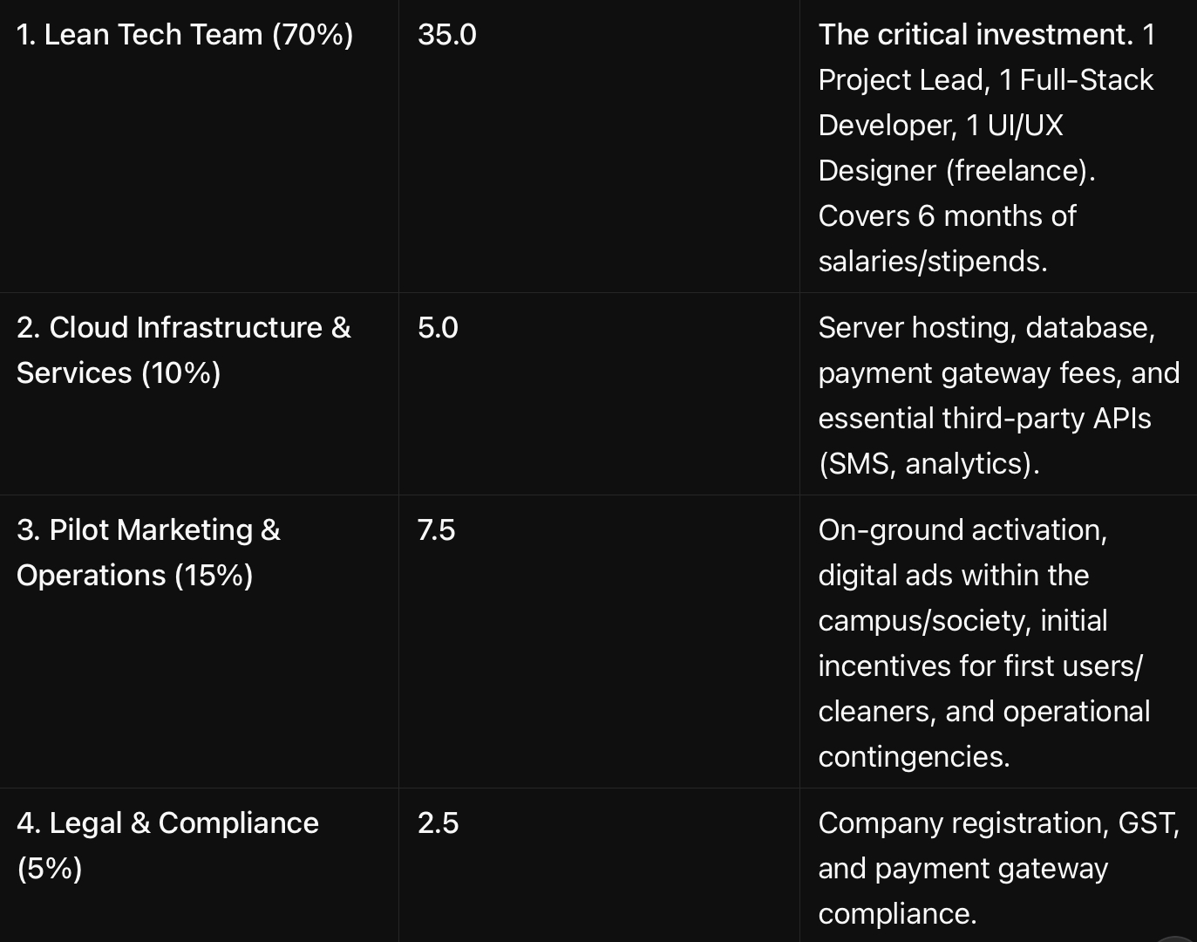
1. Lean Tech Team (70%) 35.0 The critical investment. 1 Project Lead, 1 Full-Stack Developer, 1 UI/UX Designer (freelance). Covers 6 months of salaries/stipends.
2. Cloud Infrastructure & Services (10%) 5.0 Server hosting, database, payment gateway fees, and essential third-party APIs (SMS, analytics).
3. Pilot Marketing & Operations (15%) 7.5 On-ground activation, digital ads within the campus/society, initial incentives for first users/cleaners, and operational contingencies.
4. Legal & Compliance (5%) 2.5 Company registration, GST, and payment gateway compliance.
TOTAL 50.0

---

Key Milestones & Deliverables (6-Month Timeline)

· Month 1-2: Team formation, finalize scope, and develop MVP.
· Month 3: Soft launch to a small user group (e.g., a single hostel). Iron out bugs.
· Month 4-5: Full pilot launch across the entire campus/society. Aggressive user/cleaner onboarding. Goal: 1,000 active users, 50 active cleaners.
· Month 6: Data Collection & Validation. Operate and measure relentlessly.

---

Defining Value: The Pre-Seed KPIs

Value at this stage is measured by validated learning and traction metrics, not just revenue. We will deliver:

1. A Functional, Though Lean, Product: A working MVP that has processed real transactions.
2. Validated Unit Economics:
· Average Pledge per Campaign: Target: ₹150-₹300.
· Cleaner Payout Efficiency: Demonstrate ability to manage payouts at 80-90% of pledge.
· Contribution Margin per Transaction: (Platform Fee - Direct Costs). Target: Positive.
3. Proof of Engagement:
· Monthly Active Users (MAU): 1,000+
· Campaign Completion Rate: >70%
· User Retention (Month 1-3): Demonstrate repeat usage.
4. A Compelling Seed Round Narrative:
· A video demo of the live app.
· A deck filled with real data and user testimonials.
· A clear, proven plan for scaling from 1 campus to 1 city.

---

The Roadmap: From Pilot to Seed

Pre-Seed (Now - ₹50 Lakhs)

· Goal: Prove the core transaction works in one closed loop.
· Output: Validated KPIs, a working MVP, and a compelling data pack.

Seed Round (Target: ₹3-5 Crores)

· Goal: Scale the validated model to an entire city (e.g., Bangalore).
· Use of Funds: Build the scalable tech platform, expand the team, and execute the city-wide GTM strategy.
· Valuation Driver: De-risked model with proven unit economics.

Our ask of ₹50 Lakhs is the key to unlocking the ₹5 Crore Seed Round. We are not asking for money to build a dream; we are asking for the resources to prove that the dream is a viable, fundable business.

---

Appendix: Pre-Seed Projections (Pilot Phase)

Metric Pilot Target
Duration 6 Months
Pilot Location 1 Campus/Large Society
Active Users 1,000
Active Cleaners 50
Campaigns Completed 500
Total Transaction Value ₹1,00,000 - ₹2,00,000
Platform Revenue (10% fee) ₹10,000 - ₹20,000
Key Validation Positive Contribution Margin

This pilot is designed to be a low-cost, high-insight experiment that dramatically increases our valuation and appeal for the next stage of our journey.

